Name:  Class: | ____________________________________  ________________ |  | Date: ___________
 | Year 11 Essential Mathematics Unit 2  SCORE:  /24 ___  Mini Test 2.6 2018  Topic – Time and timetables  Full working out MUST be shown to get full marks for each question.
Total Time: | 30 minutes
Weighting: | 1%
Equipment: | To be provided by the student: Pen, pencil, ruler, scientific calculator,1 single sided page of A4 notes

Question 1
Convert the following times below into different units. (6 marks)
- ¼ century into years

- 669 days into months

- 90 days into years

- 3.5 years into weeks

- 367,200 seconds into days

- 12,340 minutes into weeks

Question 2
Complete the following table. (5 marks)

24 hour time | 12 hour time
0013
 | 4:56 pm
0934
2156
 | 12:16pm

Question 3
Marcus is looking forward to his favourite tv show which starts at 5:30pm. It is currently 2:55pm. How long does he need to wait? (2 marks)

Question 4
Bradley is picking his 3 friends Steve, Marsha and Beryl to go to a restaurant. It will take 11 minutes to get from Bradley’s house to Steve’s, 7 minutes to get from Steve’s house to Marsha’s, 6 minutes to get from Marsha’s to Beryl’s and then 4 minutes to get from Beryl’s house to the restaurant. What time does Bradley need to leave home if the restaurant booking is for 7:30pm? (4 marks)

Question 5 [7 marks: 1, 1, 2, 2 & 1 mark]

Mark needs to get from Roma Street Station in Brisbane to the Brisbane Domestic Airport as close to 1:30pm as he can. Below are two timetables - one for the train, the other for a bus:

Train timetable:

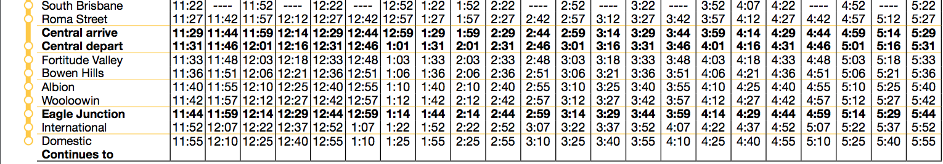

Bus timetable (Note: Brisbane Coach Terminal = Roma Street Station):

- What time would you need to depart Roma Street to arrive at the airport in time for the train?

- What time would you need to depart Roma Street to arrive at the airport in time for the bus?

- How long will it take you to travel to the airport via the train? Show working out

- How long will it take you to travel to the airport via the bus? Show working out

- Which method of transport was faster?

Question 6 [6 marks: 1, 1, 1, 1, 2 marks]

Below is the tide chart for Fremantle from Monday 9th October to Sunday 15th October 2017, showing the 24-hour time and heights of low and high waters:

Use the tide chart to answer the following questions:

- On the tide chart, circle all the low tides, both time and heights.

- How many high tides were there over the weekend?

- If you wanted to leave Fremantle by boat on a high tide on the morning of Sunday 15th, what was the earliest time you could leave?

- You were ready to come back onto land by 9pm on Sunday 15th, however you had to wait for a high tide. What was the earliest time you could bring the boat in?

- How much time passed between the high tides on Sunday 15th October?

